**Section 5**

**Code**

**for**

**Bug Tracker Application**

**Version 1.0 approved**

**Prepared by Group 12**

**CSCI222, University of Wollongong**

27 October 2016

Contents

1. Code Listing 3

2. Unit Test Class 4

2.1 Add Bug 4

2.2 Register 4

2.3 Edit Profile 5

2.4 Login 5

2.5 View Bug 6

Figure 1 Code Listing 3

Figure 2 Add Bug Unit Test 4

Figure 3 Register Unit Test 4

Figure 4 Edit Profile Unit Test 5

Figure 5 Login Unit Test 5

Figure 6 View Bug Unit Test 6

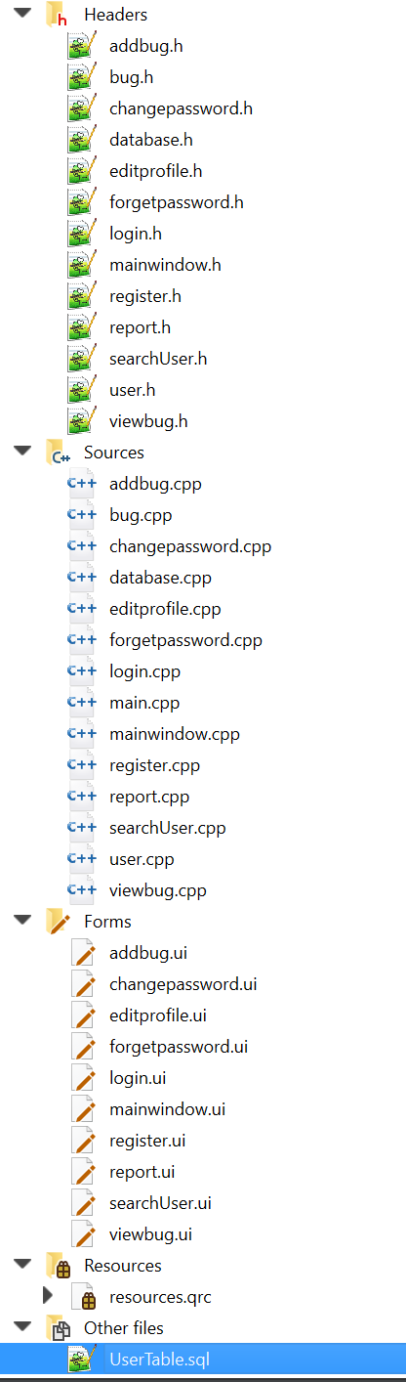

# Code Listing

List of all the files used in the application.

Figure 1 Code Listing

# Unit Test Class

## Add Bug

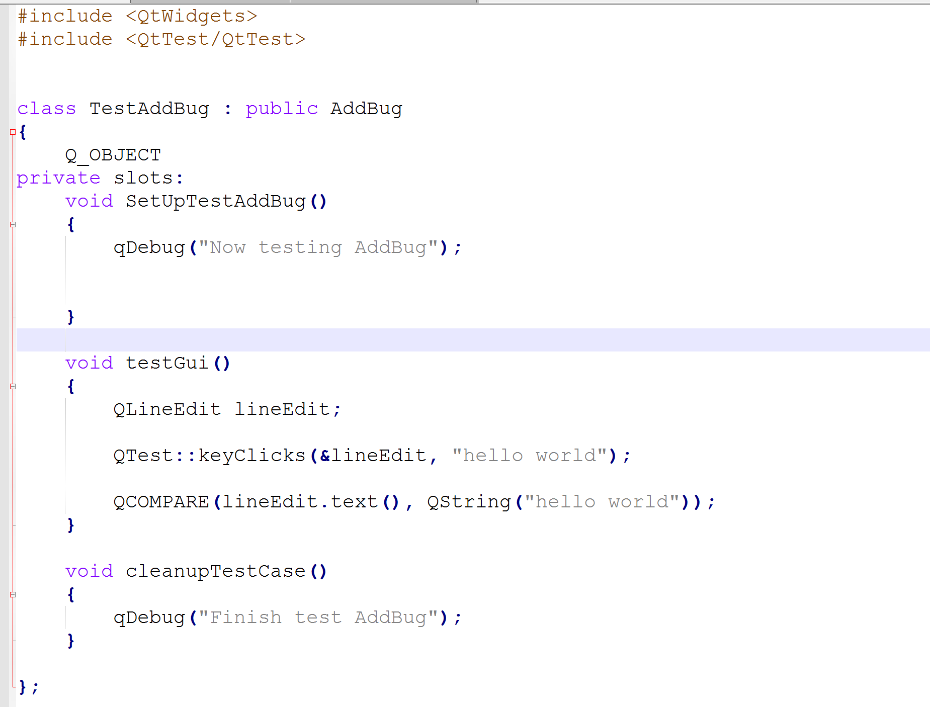

Figure 2 Add Bug Unit Test

## C:\Users\njs10\AppData\Local\Temp\Rar$DRa0.317\unittest\Register.PNG Register

Figure 3 Register Unit Test

## Edit Profile

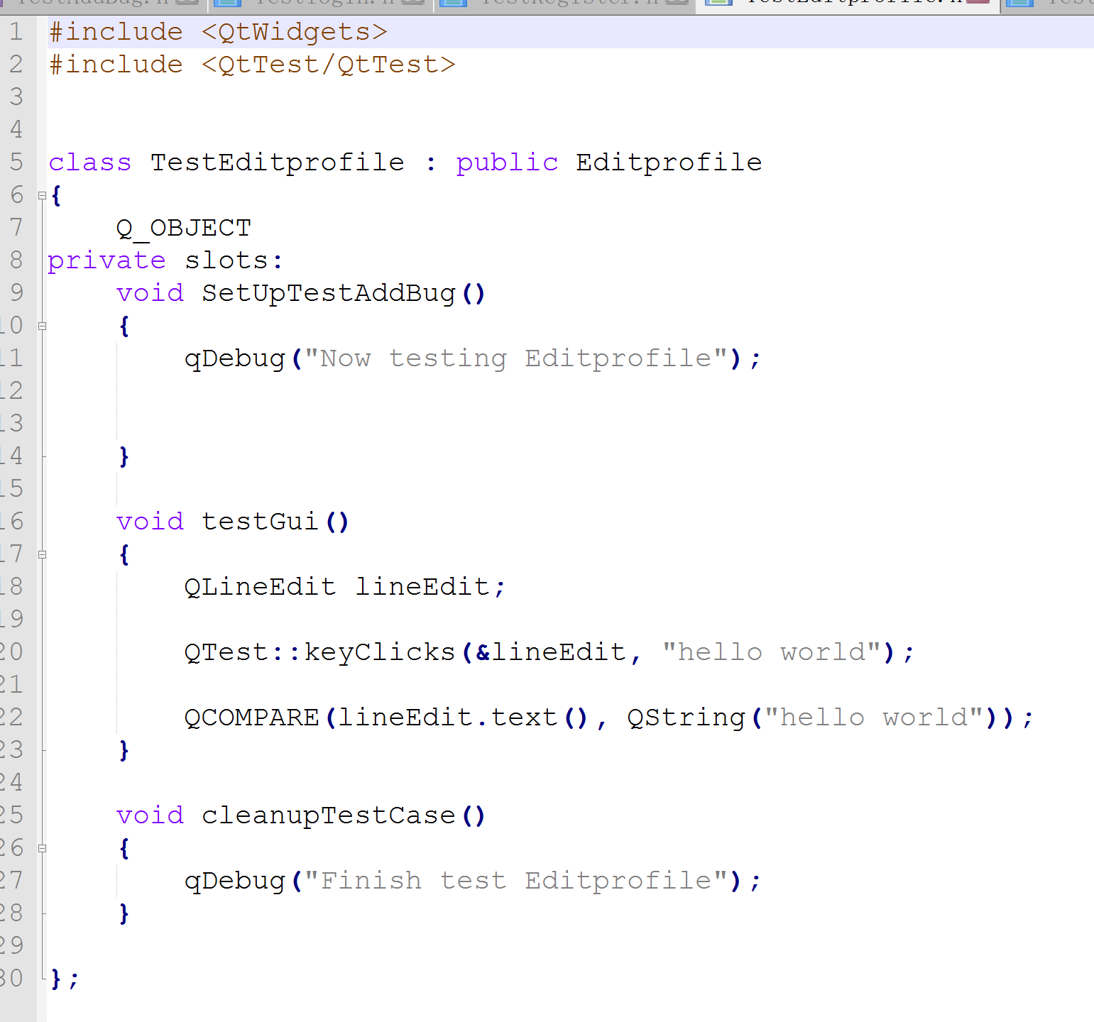

Figure 4 Edit Profile Unit Test

## Login

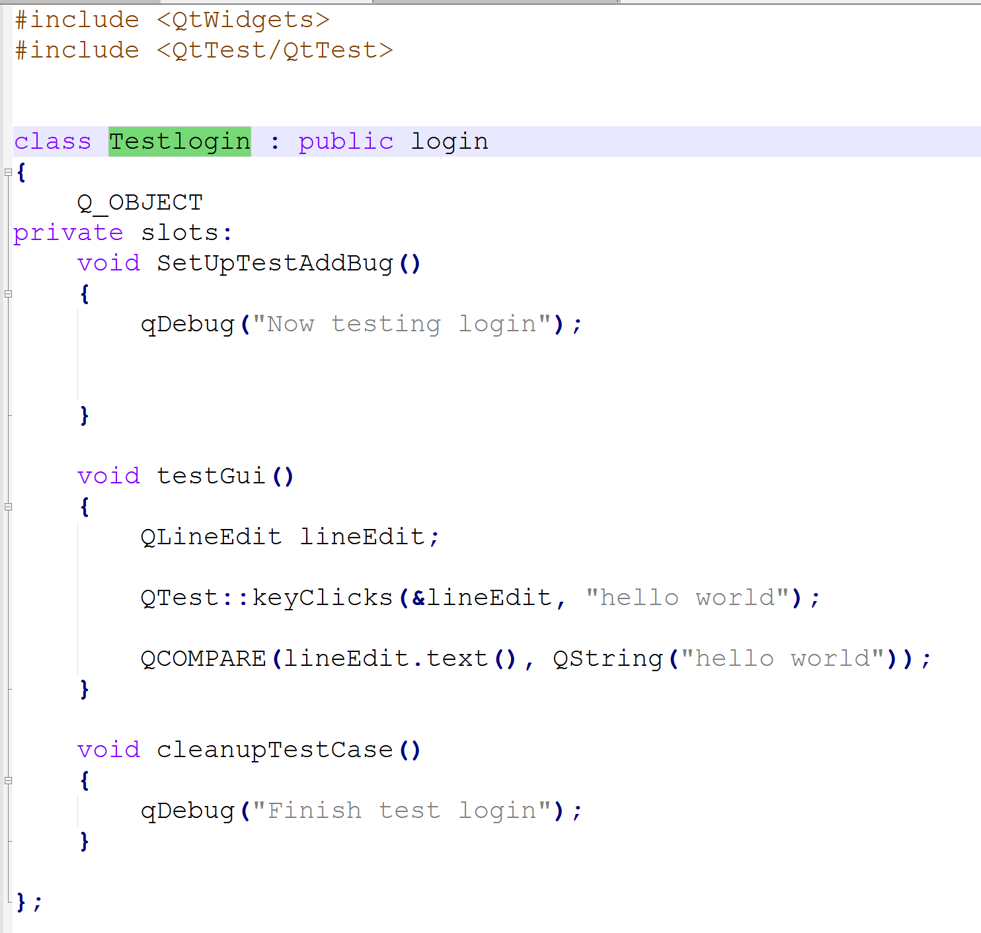

Figure 5 Login Unit Test

## View Bug

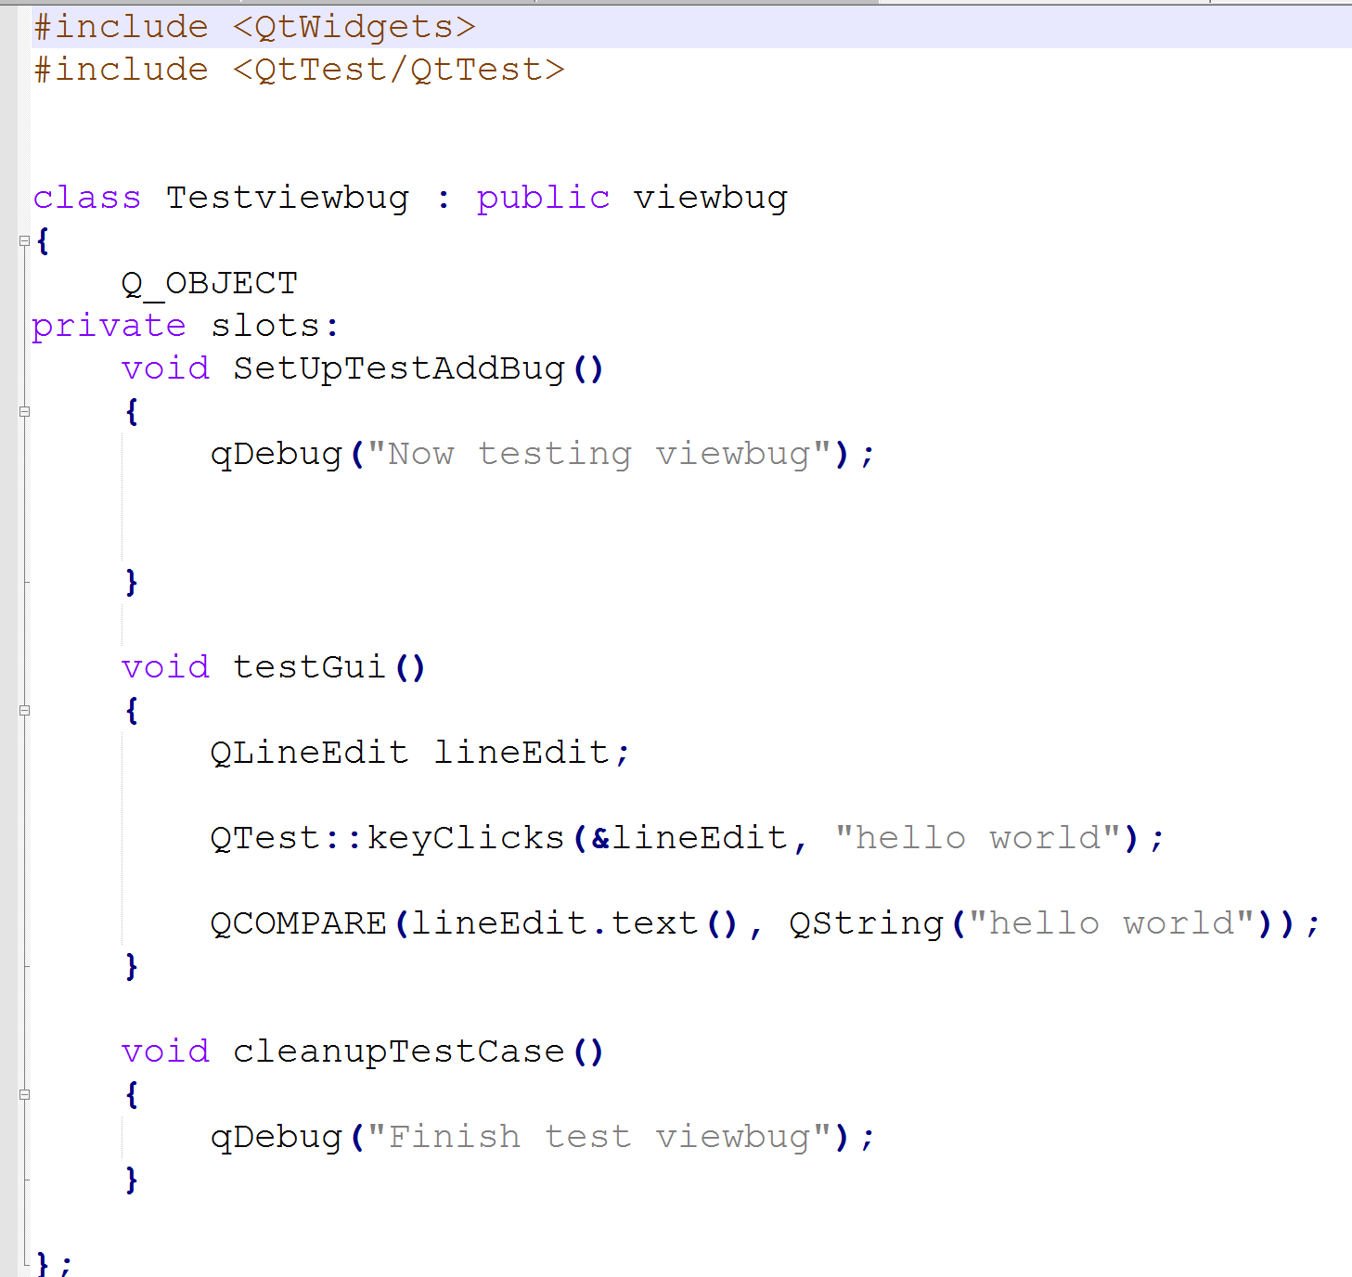

Figure 6 View Bug Unit Test